यूको बैंक  UCO BANK
सम्मान आपके विश्वास का HONOURS YOUR TRUST

Selling of Our Bank Vehicle Bearing No. GJ-05 JH 3489 (MARUTI SWIFT VXI) Under Surat Zone

The details are as under;

Date of Commencement | 01/03/2024
Last date for submission of tender | 21/03/2024 up to 05.00 P.M.
Opening of Financial Bid | 21/03/2024 at 5:30 PM
Visit of Vehicle | 01/03/2024 to 21/03/2024 ( IN BANK TIMING EXCLUDING HOLIDAY)
Base Price | 2,30,000/- (Below base price of the vehicle bids will not be eligible.)
Allotment of Vehicle | H-1 Bidder (Highest Price of Bidder)
Issue of tender document | Tender documents can be download from https://www.ucobank.co.in
Bids to be submitted | UCO Bank, Zonal Office, 2nd floor, Riddhi Shoppers,  Opp. Star Bazar, Adajan-Hazira Road, Adajan -395009.

यूको बैंक, सामान्य प्रशासन विभाग, अंचल कार्यालय, सुरत – 395009
UCO Bank, Zonal Office, 2nd Floor, Riddhi shoppers, Adajan SURAT – 395009
फोन Phone: 0261-2797500 ई-मेल E-mail: zosurat.gad@ucobank.co.in

BIDS FOR SELLING OF BANK VEHICLE BEARING NO. GJ-05 JH 3489 (MARUTI SWIFT VXI)

SR. NO. | MAKE | MODEL | ITEMS/ASSECCORIES | AVAILABLE | REMARKS
1. | MARUTI SWIFT VXI | 2014 | ORIGINAL RC | YES
2. | MARUTI SWIFT VXI | 2014 | KEYS -02 NOS. | YES
3. | MARUTI SWIFT VXI | 2014 | ORIGINAL PURCHASE PAPERS | NO | XEROX AVAILABLE
4. | MARUTI SWIFT VXI | 2014 | SPARE WHEEL | YES
5. | MARUTI SWIFT VXI | 2014 | TOOLS KIT | NO
6. | MARUTI SWIFT VXI | 2014 | INSURANCE | AVAILABLE
7. | MARUTI SWIFT VXI | 2014 | BASE PRICE | Rs.2,30,000/- | Below base price of the vehicle bids will not eligible.
8. | Allotment of Vehicle |  | H-1 Bidder (Highest Price of Bidder)
NOTE: AFTER ALLOTMENT OF H-1 BIDDER
- NAME OF OWNER TO BE IMMEDIATE CHANGE ON THE NAME OF PURCHESER & CONCERN ALL FORMALTIES & CHARGES WILL BE BORN BY THE BIDDER.
- FULL PAYMENT TO BE MADE ON THE NAME OF OUR BANK “ZONAL MANAGER ZONAL OFFICE UCO BANK SURAT”

APPLICATION BIDS OF VEHICLE

SR. | NAME OF APPLICANT | DECLERATION & DATE FOR INSPECTION OF VEHICLE | PRICE BID (Rs.) | REMARKS
 |  |  |  | All the above terms & conditions understood by bidder.

NAME & SIGNATURE OF BIDDER

Report on Fair Market Valuation Analysis of Vehicle (Maruti Swift VXI
Reg. No. GJ 05 JH 3489)

Date: 28.02.2024



by:
Meet J Patel

Registered Valuer (P&M) (Reg. No. : IBBI/RV/05/2020/13414)
Address: 42, 3rd Floor, Atlanta Shoppers, Beside Reliance Market, Vesu, Surat. 395007

M: 8866379673, E-Mail: meetpatel64.mp@gmail.com

Date: 28th February, 2024
To,
The Zonal Manager, UCO Bank,
Zonal Office, Surat.

Sub: Determination of Fair Market Value of Specified Vehicle (Maruti Swift VXI, Reg No. GJ 05 JH 3489)

Dear Sir,

We refer to our engagement dated 27th February, 2024 for carrying out the valuation analysis of Vehicle (Maruti Swift VXI, Reg No. GJ 05 JH 3489) situated at UCO Bank, Zonal Office, Surat. We are enclosing our report along with this letter.
In the attached report, we have summarized the Valuation analysis of vehicle (Maruti Swift VXI, Reg. No. GJ 05 JH 3489) as on 27th February, 2024 (“Valuation Date”) together with the description of methodologies used and limitation on our Scope of Work.
This Report has been prepared by Mr. Meet J Patel for the asset class ‘Plant & Machinery’, based on the information provided by you, and verification of the Assets in connection with the determination of estimated Fair Value of the Vehicle. The information and/ or documents used by the Valuer in preparing this Report have been obtained from bank and has not been verified. We assume no responsibility and make no representations with respect to the accuracy or completeness of any information provided by and on behalf of bank. Our report is subject to the scope and limitations detailed hereinafter. As such the report is to be read in totality, and not in parts, in conjunction with the relevant documents referred to herein and in the context of the purpose for which it is made.
This report has been prepared for with a limited purpose / scope, i.e. for Sale purposes and utility of the Bank and will be confidential and for use only to whom it is issued. It must not be copied, disclosed or circulated in any correspondence of discussions with any person, except

to whom it is issued and to those who are involved in this transaction and for various approvals for this transaction.
Based on our analysis of the current economic and industrial environment relative to the historical information as provided by the client and subject to our comments as detailed in this report, we have arrived at an estimated Fair Market Value, Realizable Value & Distress Sale Value of the Vehicle (Maruti Swift VXI, Reg. No. GJ 05 JH 3489) at INR 2.30 Lakhs, INR
1.95 Lakhs & 1.72 Lakhs respectively.

Particulars | Fair Market Value  (In INR)
Vehicle (Maruti Swift VXI) Wide Reg. No. GJ 05 JH 3489,  Chassis No. MA3EHKD1S00721578 | 2,30,000
Total | 2,30,000

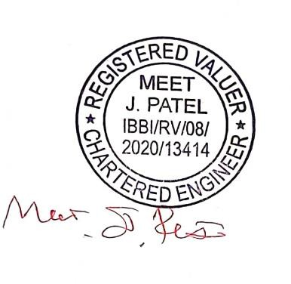
Submitted by:
Meet J Patel Registered Valuer

IBBI/RV/08/2020/13414

Table of Contents
SECTION – I 4
- Preamble 4
- Basis of Valuation 4
- Definition of Fair Value 4
- Definition of Realizable Value 5
- Definition of Distress Sale Value 5
- Pecuniary Interest Declaration 5
- Assumptions and limiting conditions 6
- Scope of work 6
SECTION – II 7
- Valuation of Vehicles 7
  - Basis and Methodology 7
  - Sales Comparison method 7
  - Notes and Observations 8
  - Valuation Summary: 8
  - Photos of the vehicle 9

SECTION – I

Preamble

Name of the Client | M/s. UCO Bank, Zonal Office, Surat.
Name of the Valuer and Reg. No. | Meet J Patel IBBI/RV/08/2020/13414
Purpose of Valuation | Fair Market Valuation of specified Vehicle (Maruti Swift VXI) Wide Reg. No. GJ 05 JH 3489 for Sale Purpose  Chassis No. MA3EHKD1S00721578
Assets Valued | Private Vehicle
Date of Valuation | 27th February, 2024
Conduct of Valuation/ Methodology | While Conducting the valuation, we have relied upon International Valuation Standards issued by the  International Valuation Standards Council (IVSC).
Date of Report | 28th February, 2024

The information and facts were observed and gathered from the client. These are recorded in our valuation report and the value evaluated is based on current market trends and valuation norms.

Basis of Valuation

Fair Value on as is where is basis is considered for this Valuation exercise. To determine the valuation, we have carried out an inspection of the subject assets. We have adopted Sales Comparison Method under Market Approach and all methodologies have been described in the attached report.

Definition of Fair Value

‘Fair Market Value’ is defined as “estimated realizable value of the assets, if they were to be exchanged on the date of valuation between a willing buyer and a willing seller in an arm’s length transaction, after proper marketing and where the parties had acted knowledgably, prudently and without compulsion.
Indian Accounting Standard (Ind AS) defines fair value as the price that would be received to sell an asset or paid to transfer a liability in an orderly transaction between market participants at the measurement date.

A fair value measurement is for a particular asset or liability. Therefore, when measuring fair value an entity shall consider the characteristics of the asset or liability if market participants would take those characteristics into account when pricing the asset or liability at the measurement date. Such characteristics include, for example, the following:

  - the condition and location of the asset; and
  - Restrictions, if any, on the sale or use of the asset.

A fair value measurement assumes that the transaction to sell the asset or transfer the liability takes place either:
- in the principal market for the asset or liability; or
- in the absence of a principal market, in the most advantageous market for the asset or liability.

Definition of Realizable Value

“Realizable value is the estimated selling price of an asset in the ordinary course of business, less the estimated costs of completion and the estimated costs necessary to make the sale”
The aforesaid Market Value is normally realizable in a perfect market scenario. However, when Bank / financial institution wishes to recover its money by sale / auction of the assets in one go (complete payment at one time) it results in a discounted payment. Further, marketability may also be reduced because this kind of assets has its maximum value in its existing situation and not in ‘Ex Situ’. Further costs may also be required to be incurred in advertising and management of sale process. In our professional opinion the realizable value may be in the region of a discount of 10% to 20% over the Fair Market Value.

Definition of Distress Sale Value

The Distress Sale Value has to be considered for Cost of sale processes like advertisement, brokerage and a reasonable time period for marketing, in such transactions, payments are deferred in nature and installments are spread over a period of time. Further, the valuation report is issued to the bank for the sale purpose. Bank wants to sale the premises to recover their money. In such type of transactions, normally the prospective buyer is in a better bargaining position than the seller. It is virtually a buyer’s market. Further, the transection normally happens in a forced-sale situation wherein the seller has to liquidate by compulsion or is in urgent need of funds. All these result in a distress-sale scenario. The distress sale value would be in the range of a discount of 20% to 40% over the Fair Market value.

Pecuniary Interest Declaration

The Valuer has no pecuniary interest in the said asset, past, present or prospective, and the opinion expressed is free of any bias in this regard. The Valuer strictly follows the code of conduct of his Registered Valuation Organization of IBBI.

Assumptions and limiting conditions

During the course of this valuation exercise/process, the following limitations and assumptions were made, which require a special mention:

- The statements of facts presented in the report are correct to the best of Valuer’s knowledge.
- The analysis & conclusions are limited only by the reported assumptions & conditions.
- The valuer has no interest in the subject Asset
- The valuer’s fee is not contingent upon any aspect of the report
- The valuation was performed in accordance with the ethical code and performance standards
- The valuer has experience in the category of the asset class being valued
- Possession of any copy of this report does not carry with it the right of publication, nor may be used for any purpose by any one, except the addressee and the asset owner, without the previous written Consent of the valuer, and in any event, only may be revealed in its entirety.
- The analysis of this report is based on publicly available information, Industry Benchmark / Standards or our Professional Judgment, as the case may be, where the information has not been furnished by the company
- The condition assessment and the estimation of useful life is based on visual observations / review of maintenance, performance & service records and based on professional judgment. We have not carried out any structural design or stability study; we have also not carried out any physical tests to assess
- Individuals who are familiar with valuation-assessment of such assets carried out the inspection, due diligence and condition-assessment of the assets. However, we do not opine on, nor are we responsible for its conformity to any health, safety, environmental or any other regulatory requirements that were not readily apparent to our team of experts during their inspection
- This valuation is valid only for the purpose mentioned in this report; and neither intended nor valid to be used for any other purposes.
- The valuation is not a precise science and the conclusions arrived at in many cases will be subjective and dependent on the exercise of individual judgment. Hence, there is no indisputable single value and we normally express our conclusion as falling within a likely range.
- Whilst we consider our conclusions to be both reasonable and defensible based on the information available to us, others may place a different value based on the same information.

Scope of work

Our scope of work includes Fair market Valuation of Specified Vehicle (Maruti Swift VXI, Reg. No. GJ 05 JH 3489) as on the date of valuation.

SECTION – II

Valuation of Vehicles

- Basis and Methodology:

Normally Sales Comparison Method is adopted for valuation of vehicle under market approach.

- Sales Comparison method:
The sales comparison approach also known as market approach is the systematic gathering, recording and analysing data of similarly affected properties recently sold and comparing sales to the contaminated property being valued. When adequate data exist for similarly affected properties, this approach is considered the most objective and supportable.
The sales comparison approach requires sufficient sales of similar properties. As in the general sales comparison approach when data on comparable contaminated properties are limited, the valuer should expand strata, the period from which sales are drawn, and geo-economically defined areas. However, appropriate adjustments must be made to ensure that proper comparability is achieved. Rather than relying only on the limited data available for similarly contaminated property, sales of similar uncontaminated (or unimpaired) property can also be used.
In this way a benchmark, unencumbered value can be established for the subject property, after which adjustments can be made for the contamination. Such adjustments should be based on the cost to cure (properly discounted or amortized), imposed limitations on use, increased insurance and financing costs, and potential liability.
This is the process wherein joint efforts of valuers and environmental expert are needed. The contribution of the valuer is to undertake valuation of impaired property or as if unimpaired but comparable in characteristics whereas the contribution of environmental engineer is to compare the contaminant present and the level of contamination of the comparable contaminated properties identified by the valuer with the subject property proposed to be valued.

The following steps are followed in this method:
  - Identification of contaminated properties.

Analyses and Comparison
  - Adjustment of prices of comparable properties

Determination of the value estimate or stigma assessment

- Notes and Observations:
  - During our visit, we inspected the Vehicle available at site.
  - The Client has provided us with the Registration Certificate of asset available at the site that we verified during our visits. The information had provided in terms of Make, Date of Registration, Vehicle Reg. No. and other relevant asset information.
  - Evaluation was carried out keeping in view machinery and equipment’s present condition, economic life, technological advancement and future usage.
  - We have arrived at the fair value figure of vehicle with our experience in the evaluation of the similar type of vehicles and from discussions with automobile experts.

- Valuation Summary:

Particulars | Fair Market Value  (In INR)
Vehicle (Maruti Swift VXI) Wide Reg. No. GJ 05 JH 3489,  Chassis No. MA3EHKD1S00721578 | 2,30,000
Total | 2,30,000

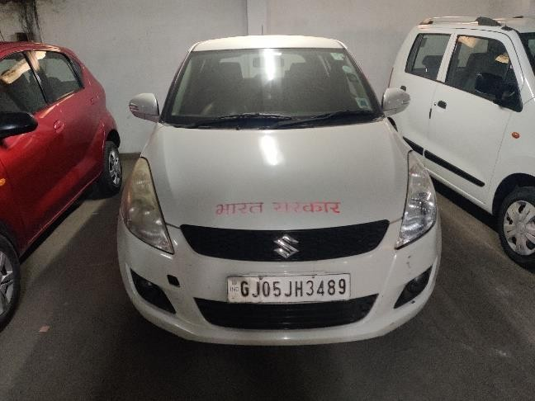
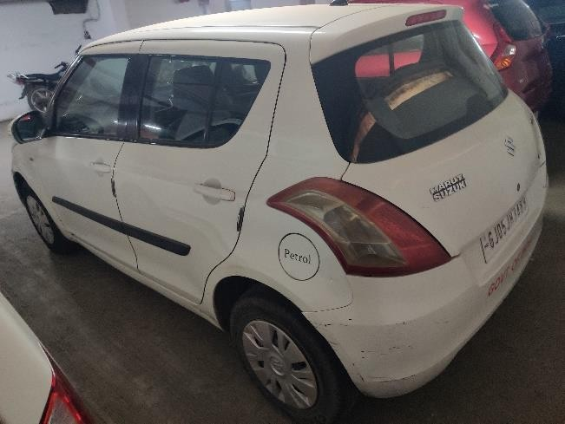
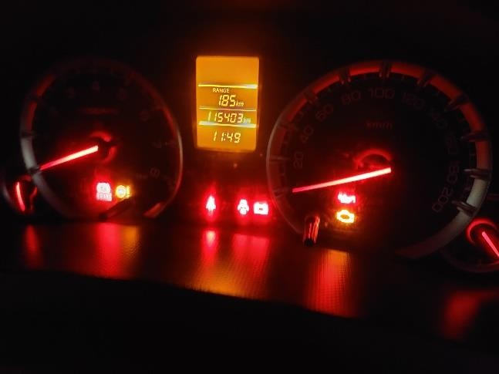
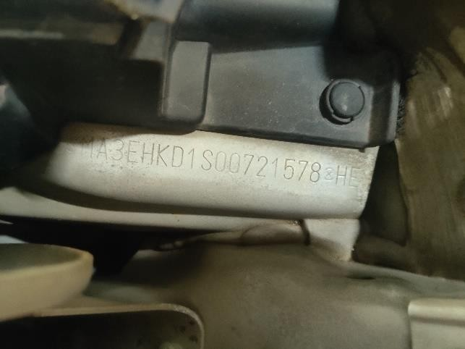
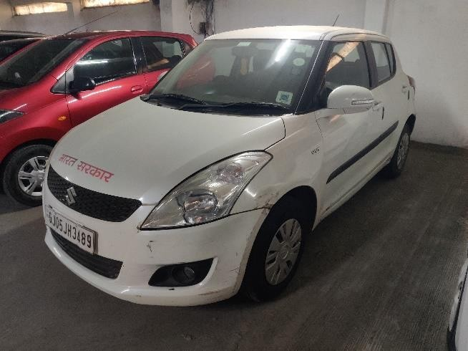
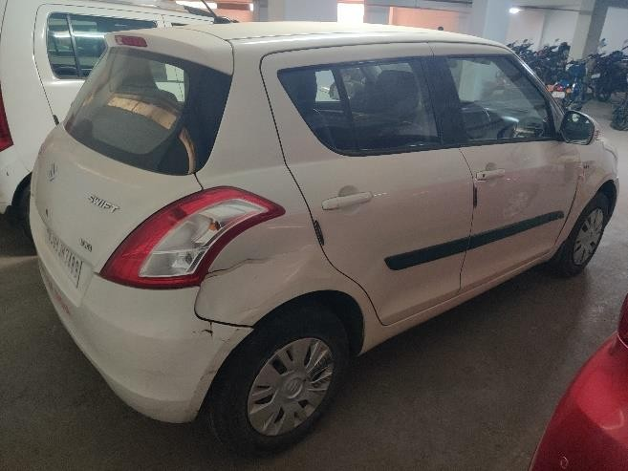
- Photos of the vehicle:

